**IMAGE RECOGNIZER**

## A Project Report

Submitted in partial fulfillment of the Requirements for the award of the Degree of

### BACHELOR OF SCIENCE (INFORMATION TECHNOLOGY)

**By**

Rhythm Shah UID / 20BIT053

**Under the esteemed guidance of Prof.**

**Wilson Rao and Prof. Bertilla Fernandez**



**DEPARTMENT OF INFORMATION TECHNOLOGY JAI HIND COLLEGE**

***(Autonomous)***

**MUMBAI, 400020 MAHARASHTRA 2022-23**

**JAI HIND COLLEGE**

***(Autonomous)***

**MUMBAI, 400020 MAHARASHTRA**

**DEPARTMENT OF INFORMATION TECHNOLOGY**



## CERTIFICATE

This is to certify that the project entitled, “Image Recognizer”, is bonaﬁed work of RHYTHM SHAH bearing UID (20BIT053) submitted in partial fulﬁllment of the requirements for the award of degree of BACHELOR OF SCIENCE in INFORMATION TECHNOLOGY from Jai Hind College Autonomous (University of Mumbai).

## Internal Guide Coordinator

**External Examiner**

**Date: College Seal**

**DECLARATION**

I hereby declare that the project entitled, “Image Recognizer” done at Jai Hind College, has not been in any case duplicated to submit to any other university for the award of any degree. To the best of my knowledge other than me, no one has submitted to any other university.

The project is done in partial fulﬁllment of the requirements for the award of degree of BACHELOR OF SCIENCE (INFORMATION TECHNOLOGY) to

be submitted as ﬁnal semester project as part of our curriculum.

## Name and Signature of the Student

**ACKNOWLEDGEMENT**

I would like to express my thanks to the people who have helped me most throughout my project. I am grateful to my Prof. Miss. Bertilla Fernandes for nonstop support for the project. I can’t say thank you enough for her tremendous support and help.

I owe my deep gratitude to our HOD of Information Technology Department Mr. Wilson Rao who took keen interest in our project work and guided us all along, till the completion of our project work by providing all the necessary information for developing a good system.

At last but not the least I want to thank all of my friends who helped/treasured me out in completing the project, where they all exchanged their own interesting ideas, thoughts and made this possible to complete my project with all accurate information. I wish to thank my parents for their personal support or attention who inspired/encouraged me to go my own way.

## ABSTRACT

An image recogniser is a system that can automatically generate a natural language description of an image. It is a type of machine learning model that combines techniques from computer vision and natural language processing to generate captions for images.

The development of image caption generation models has been motivated by the growing need for image annotation in a variety of applications, such as image retrieval, visual search, and assistive technologies for the visually impaired. The goal of image caption generation is to generate captions that are both relevant to the image and grammatically correct, as well as semantically similar, contextually relevant, and informative to the human reader.

# **TABLE OF CONTENTS**

## INTRODUCTION 10

1.1 **Background**……………………………………………………………………….10

1.2 **Objectives**…………………………………………………………………………11

1.3 **Purpose, Scope, and Applicability**……………………………………………...12 1.3.1 Purpose…………………………………………………………………….12 1.3.2 Scope………………………………………………………………………12 1.3.3 Applicability……………...…………………………………………………….13

1.4 A**chievements**…………………………………………………………………….13 1.5 **Organization of Report**…………………………………………………………13

## SURVEY OF TECHNOLOGIES 14

1. **REQUIREMENT AND ANALYSIS** 1**6**

3.1 **Problem Definition**…………………………………………………………..…..16

3.2 **Requirement Specification**……………………………………………….……..18 3.3 **Planning and Scheduling**………………………………………………….…....19

* 1. **Software and Hardware Requirements**………………………………….……..21
  2. **Preliminary Product Description**……………………………………………. 22
  3. **Conceptual Models**……………………………………………………………...23

## SYSTEM DESIGN 32

4.1 **Basic Modules**……………………………………………………………. 32

1. IMPLEMENTATION AND TESTING 35

5.1 Implementation Approach……………………………………………………..35

5.2 Coding Details and Code Efficiency…………………………………………...34 5.2.1 Code Efficiency…………………………………………. 58

5.3 Testing Approach…………………………………………. 59

5.3.1 Unit Testing…………………………………………. 59

5.3.2 Integration Testing…………………………………………….. 59

5.3.3 System Testing…………………………………………...........................59

5.4 **Modifications and Improvements**……………………………………………...60

## RESULTS AND DISCUSSION 61

6.1 **Test Reports**…………………………………………………………….61

6.2 **User Documentation**………………………………………………….....62

## CONCLUSION 68

7.1 **Conclusion**………………………………………………………..….68

* 1. **Limitations of the System**…………………….……………………….68
  2. **Future Scope of the Project**…………………..…………………....….68

### List of Figures

1. Gantt Chart…………………………………………………………….....19

2. PERT Chart………………………………………………………………20

3. Event Table…………………………………………………………….....23

4. Use Case Diagram………………..……………………………………...24

5. Structure Diagram…………………………………………………..…….25

6. Activity Diagram…………………………………………………….…..26

7. Sequence Diagram……………………………………………………….27

8. CNN Structure……………………………………………………….......27

9. State Chart Diagram………………………………………………………28

10. System Architecture ……..……………………………………………...29

11. LSTM and CNN Architecture …………………………………………...30

12. Component Diagram…………………………………………………...…30

13. Data Flow Diagram…………………………..………………………….31

14. Homepage………………..……………………………………………...33

15. Upload from files………………………………………………………...33

16. Fetch Image from google……………………………………………….34

17. Check Image.……………………………………………………………34

18. Homepage ……….…………………………………………………...…62

19. Select from files ……………………………………………………..…63

20. After selecting image………………………………………………….....63

21. After generating ……..…..………………………………………………...64

22. Select image from google………………………………………………64

23. Enter URL……………………………………………………….………...65

24. After fetching from google ……………………………………………..65

25 Recognising Image…………………………………………………...…..66

26 Uploading image ………………………………………………………...66

27 Recognising Image as Harmful/ Restricted Content …………………….67

1. **INTRODUCTION**
   1. **BACKGROUND**

Image caption generation is a challenging problem in computer vision and natural language processing, with applications in image search, content-based image retrieval, and assistive technologies for the visually impaired. The aim of this project is to develop an image caption generator using deep learning techniques and Python programming language. The system uses a pre-trained convolutional neural network (CNN) to extract visual features from the input image and a pre-trained language model to generate natural language descriptions of the image. Two search algorithms are implemented for caption generation: Beam search and Greedy search.

The Beam search algorithm is a variant of breadth-first search that explores a fixed number of most promising candidate captions at each time step, while the Greedy search algorithm selects the highest-scoring word at each time step, without considering future consequences. Both algorithms generate a sequence of words, conditioned on the input image, and stop when a stopping criterion is met

* 1. **OBJECTIVES**

The main objective of an image caption generator is to generate a natural language description of an image.

Some specific objectives of an image caption generator include:

1. Object Recognition: The model should be able to identify and label the objects present in the image.
2. Scene Understanding: The model should be able to understand the context and layout of the image, and describe the overall scene.
3. Language Generation: The model should be able to generate grammatically correct and coherent sentences that accurately describe the image.
4. Natural Language Understanding: The model should be able to understand the nuances of natural language, such as idiomatic expressions and figurative language.
5. Human-like Description: The model should be able to generate descriptions that are similar to those that a human would give, in terms of both content and style.
6. Multimodal Understanding : Model should be able to understand the multiple modalities present in the image and generate a caption accordingly.
7. Robustness : The model should be able to generate captions even in the presence of complex scenes, cluttered images, and images with low resolution or lighting.
8. Domain-specific application: The model should be able to generate captions that are specific to a particular domain, such as wildlife, sports, or fashion.
9. Handling Novelty : Model should be able to generalize well to handle unseen images and generate caption for that.

### PURPOSE, SCOPE and APPLICABILITY

#### **Purpose**

The main objective of an image caption generator is to generate a natural language description of an image

#### **Scope**

The scope of image caption generators is quite broad, as they have the potential to be used in a variety of applications. Some examples of the ways in which image caption generators can be used include:

1. Image Retrieval: Image caption generators can be used to generate captions for images, which can then be used to improve the accuracy and efficiency of image retrieval systems.
2. Visual Search: Image caption generators can be used to generate captions for images, which can then be used to improve the accuracy and effectiveness of visual search systems, allowing users to search for images based on their textual descriptions.
3. Assistive Technologies: Image caption generators can be used to generate captions for images, which can then be used to provide information to visually impaired individuals about the contents of an image through text-to-speech or braille displays.
4. Image Annotation: Image caption generators can be used to automatically generate captions for images, which can then be used to improve the efficiency and accuracy of image annotation systems.
5. Social Media: Image caption generators can be used to generate captions for images shared on social media, which can make it easier for users to understand the contents of an image.
6. Advertising: Image caption generators can be used to generate captions for images used in advertising, which can make the ads more attractive and informative.
7. Robotics: Image caption generators can be used to provide a robot with a natural language understanding of the environment, allowing the robot to navigate and interact with its surroundings.
8. Autonomous Cars : Image caption generators can be used to generate captions for images captured by cars, which can be used to improve the decision-making process of autonomous cars.
9. Surveillance : Image caption generators can be used to generate captions for images captured by surveillance cameras, which can be used to improve the surveillance systems.

#### **Applicability**

The generated captions can assist visually impaired individuals in understanding the content of images. It can also classify an image as restricted content or not.

* 1. **ACHIEVEMENTS**

Successful implementation of a deep learning-based image caption generator using Python programming language.

* 1. **ORGANIZATION OF REPORT**

In the chapters that follow, the requirement analysis, design, implementation, testing and discussions will be described. The survey of technologies will compare and decide on a certain technology suitable for the website. I have chosen to build the app using VS Code. The languages that will be used is Python.

The requirement analysis and specification phase with decide the software and hardware requirements. The designing phase will specify the schema design along with the UI design. The implementation of the project will include designing and programming the modules according to the mentioned specifications. The testing phase will include testing all the specifications and all modules thoroughly. Then the project can be fully functional and can meet all its objectives efficiently.

1. **SURVEY OF TECHNOLOGIES**

Python(3.10.9):

Python is an interpreted, object-oriented, high-level programming language with

dynamic semantics. Its high-level built in data structures, combined with

dynamic typing and dynamic binding, make it very attractive for Rapid

Application Development, as well as for use as a scripting or glue language to

connect existing components together.

Tkinter:

Python Tkinter is a standard Python library for creating graphical user interfaces (GUIs). It provides a set of widgets and tools that allow developers to create interactive desktop applications in a platform-independent way. Tkinter is based on the Tcl/Tk GUI toolkit and provides a simple yet powerful way to build windows, buttons, menus, text boxes, and other GUI components.

Neural Networks:

The neural network is trained on a dataset of images and their corresponding captions, and learns to map images to captions using techniques such as **convolutional neural networks (CNNs)** and **recurrent neural networks (RNNs).**

Greedy Search:

Greedy search is a simple algorithm that generates the most likely next word in a sequence, based on the probability distribution of the words learned by a language model. At each step, the algorithm chooses the word with the highest probability and adds it to the sequence. Greedy search can generate captions quickly and is easy to implement, but it can also lead to suboptimal results and can get stuck in local optima.

Beam Search:

Beam search is a more advanced algorithm that generates multiple candidate captions in parallel and selects the most likely one based on a predefined criterion. Instead of choosing only the most likely next word at each step, beam search considers a fixed number of candidates and expands them simultaneously. This allows beam search to explore a larger search space and generate more diverse and accurate captions. However, beam search requires more computational resources and can be slower than greedy search.

Inception Model:

The Inception model is a deep learning architecture for image recognition developed by Google researchers in 2014. The model is based on a combination of convolutional layers and pooling layers, which are designed to process images of varying sizes and scales.

The main idea behind the Inception model is to use multiple parallel paths in the neural network to capture features of different sizes in the input image. This is accomplished by using a combination of 1x1, 3x3, and 5x5 convolutional filters in parallel, followed by pooling layers to reduce the size of the feature maps. The output of these parallel paths are concatenated and fed into the next layer.

1. **REQUIREMENT AND ANALYSIS**
   1. Problem Definition

The problem of image caption generation can be defined as the task of automatically generating a natural language description of an image. It can be formalized as a mapping between an input image and an output text, where the output text is a sequence of words that describes the contents of the image.

There are a few different ways to approach this problem, but a common method is to use a deep learning-based model that combines techniques from computer vision and natural language processing. The model takes an image as input and generates a caption by:

1. Extracting visual features from the image using a convolutional neural network (CNN)
2. Feeding the visual features into a recurrent neural network (RNN) or a transformer-based model
3. Generating a sequence of words by sampling from the output of the RNN or transformer

The main challenge in this task is to generate captions that are both relevant to the image and grammatically correct. The model needs to be able to understand the contents of the image, as well as the relationships and attributes of the objects present in the image. It also needs to be able to generate natural language descriptions that are coherent and grammatically correct.

Additionally, the generated captions need to be semantically similar, contextually relevant and informative to the human reader, even in the presence of images with complex scenes, cluttered images, and images with low resolution or lighting. And, the model should be able to generalize well to handle unseen images and generate caption for that.

#### Problem Statement

* + - * An individual can only analyze a certain number of images in a day.
      * With increase in use of social media, we also need to have algorithms to regulate the content uploaded and transfered

Thus, we need such systems which can be used on the internet and has good accuracy.

#### Existing System

* + - * The existing system is limited by the storage capacity of ones device
      * A user can only analyze a handful of images in a day

#### Proposed System

* + - * In the proposed system, this platform is a app so there is no need to block actual device memory with data of different images.
      * This system is very convenient.

### Requirement Specification

#### Functional Requirements:

* Users need to upload image
* Searching from google is available.

Python Packages Required:

1. Tensorflow,
2. Keras,
3. tkinter,
4. PIL,
5. numpy,
6. pickle
7. wget
8. pandas

#### Non-Functional Requirements

* Availability: This system will be easily available to users
* Reliability: The system is reliable and secure
* Maintainability: The system is easily maintainable and provides an easy access of resources
* The application is user-friendly and simple.
* Flexible i.e., changes can be made, if any.
* Efficiency in performance
  1. **PLANNING AND SCHEDULING**

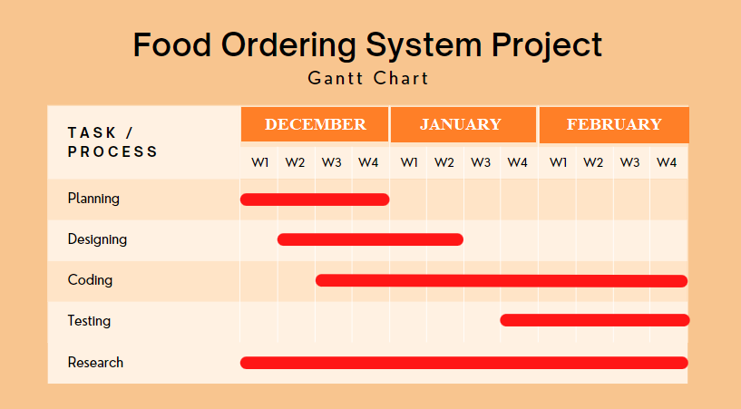

Figure 1. GANTT Chart

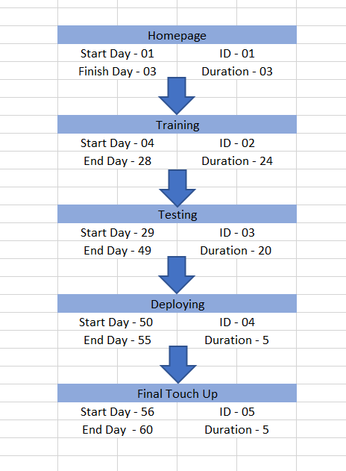

Figure 2. PERT Chart

* 1. **SOFTWARE AND HARDWARE REQUIREMENTS**

#### Software Requirements:

Operating System: Windows

Technology: Python

IDE: VS Code

#### Hardware Requirements:

Laptop/PC

RAM: 4GB and above

System type: 64-bit operating system, x64-based processor

Python Packages Required:

1. Tensorflow,
2. Keras,
3. tkinter,
4. PIL,
5. numpy,
6. pickle
7. wget
8. pandas

**3.5 PRELIMINARY PRODUCT DESCRIPTION**

* Homepage Module

When the app loads the user can select from 2 options   
1) Either open image from files  
2) Open image from url

* Open Image Module

In this module users can select the image from their device and upload it.

#### Open Image through url Module

In this module the user can add image using url from any website

#### Generate Module

This module will contain the algorithm to recognize image through cnn, lstm and rnn and will generate captions for image

#### Check Image Module

This module then further recognizes or rather classifies the image as restricted data or not

* 1. **CONCEPTUAL MODELS**

|  |  |  |  |  |  |  |
| --- | --- | --- | --- | --- | --- | --- |
| **SR NO.** | **EVENTS** | **TRIGGER** | **SOURCE** | **ACTIVITY** | **RESPON SE** | **DESTINATION** |
| 1. | Upload image | Opens files | User | Returns selected image | Image | User |
| 2. | Upload image from url | Fetching image | User | Fetches image from google | Image | User |
| 3. | Generate captions | Beam Search and greedy search algorithm | User | Generates caption for image | Caption | User |
| 4. | Check Image | Image | User | Check if restricted or not | Restrict or upload | User |

Figure 3: Event Table

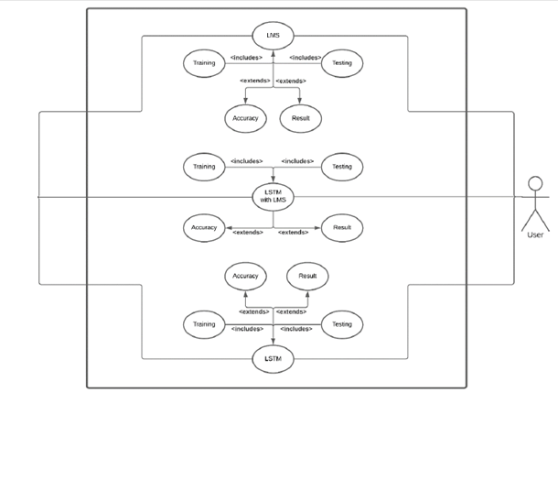

Figure 4: Use Case Diagram



Figure 5: Structure Diagram

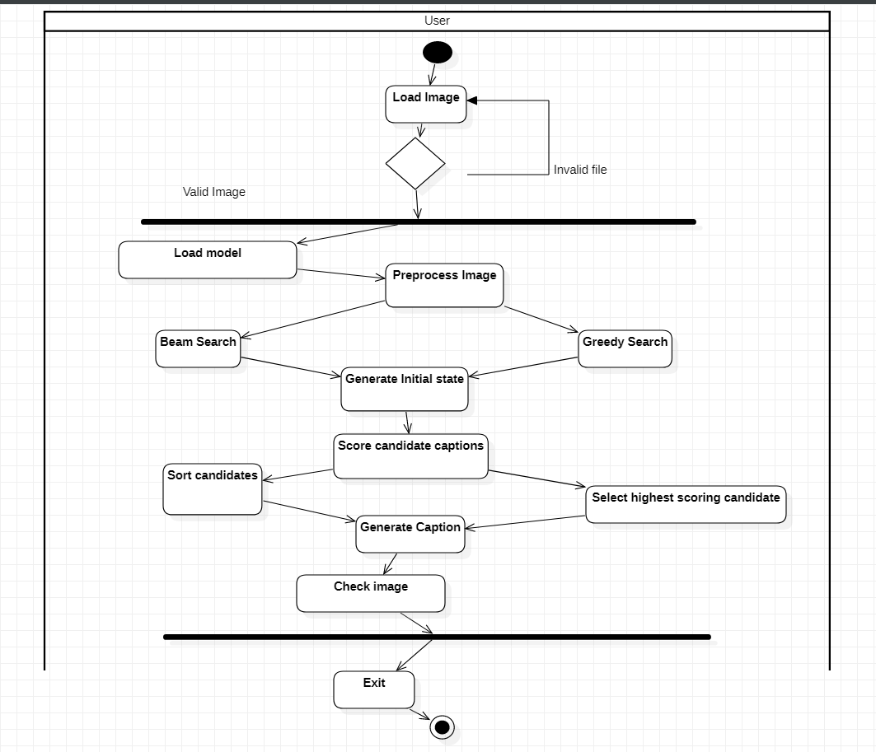

Figure 6: Activity Diagram



Figure 7: Sequence Diagram

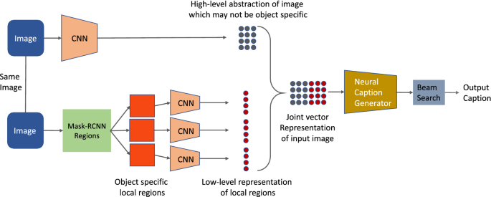

Figure 8: CNN Structure

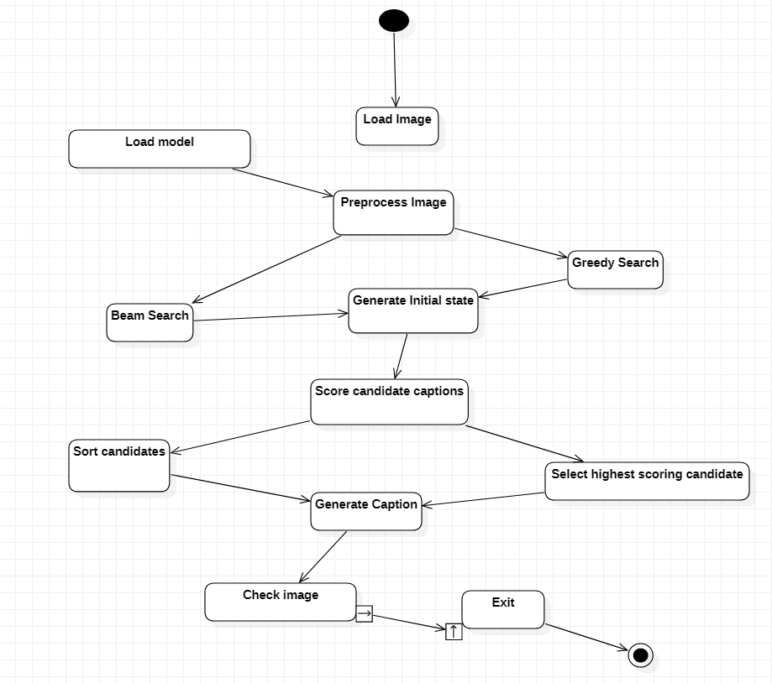

Figure 9: State Chart

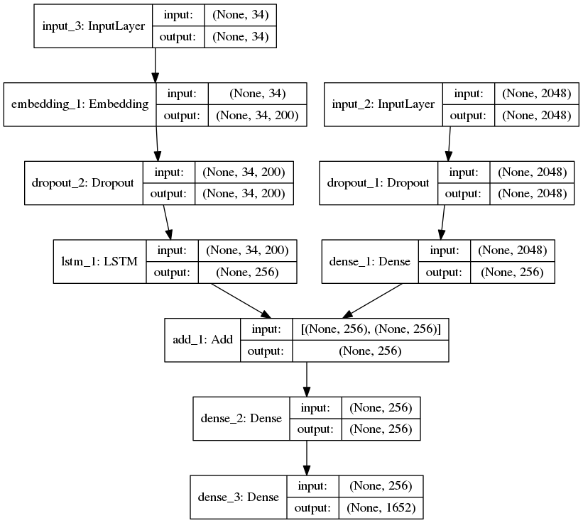

Figure 10: System Architecture

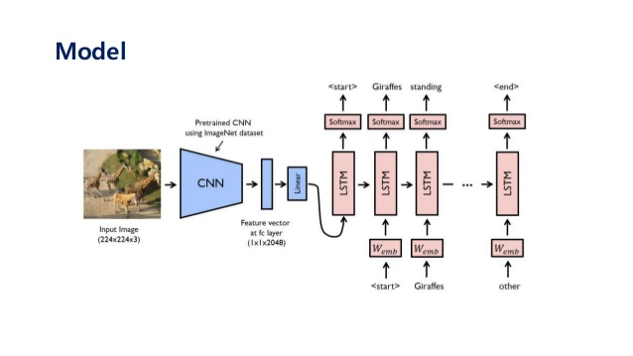

Figure 11: LSTM and CNN Architecture

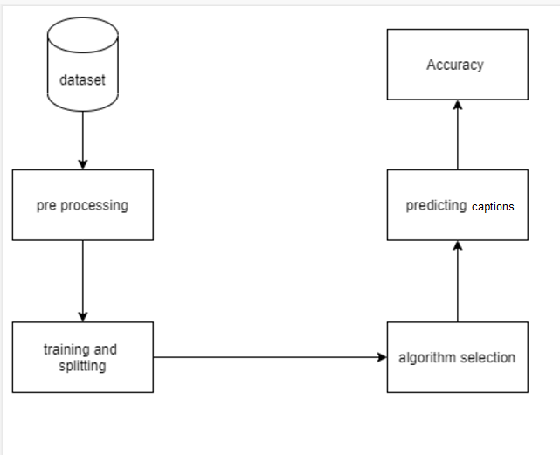

Figure 12: Component Diagram



Figure 13: Dataflow Diagram

1. **SYSTEM DESIGN**

**4.1 Basic Modules**

* Homepage Module

When the app loads the user can select from 2 options   
1) Either open image from files  
2) Open image from url

* Open Image Module

In this module users can select the image from their device and upload it.

#### Open Image through url Module

In this module the user can add image using url from any website

#### Generate Module

This module will contain the algorithm to recognize image through cnn, lstm and rnn and will generate captions for image

#### Check Image Module

This module then further recognizes or rather classifies the image as restricted data or not

**4.3 User Interface Designs**

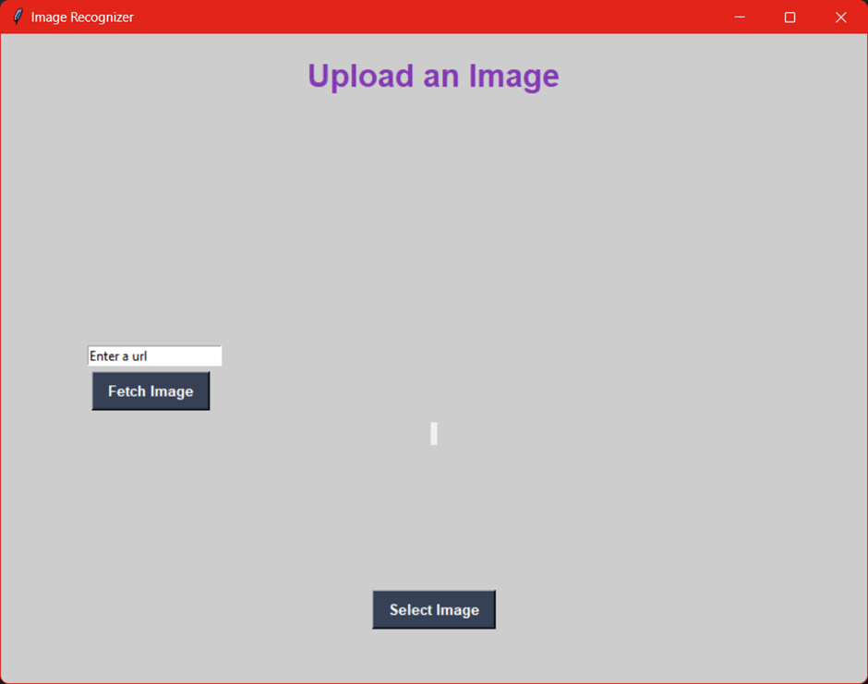

Figure 14: HomePage

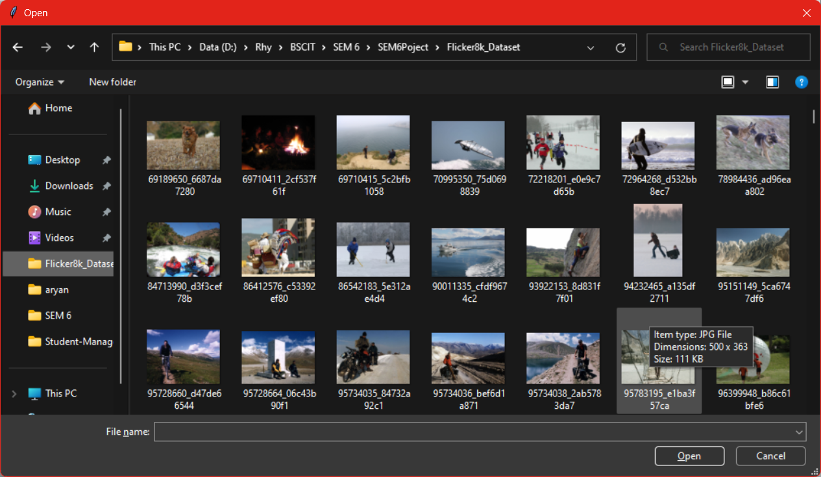

Figure 15: Upload from Files

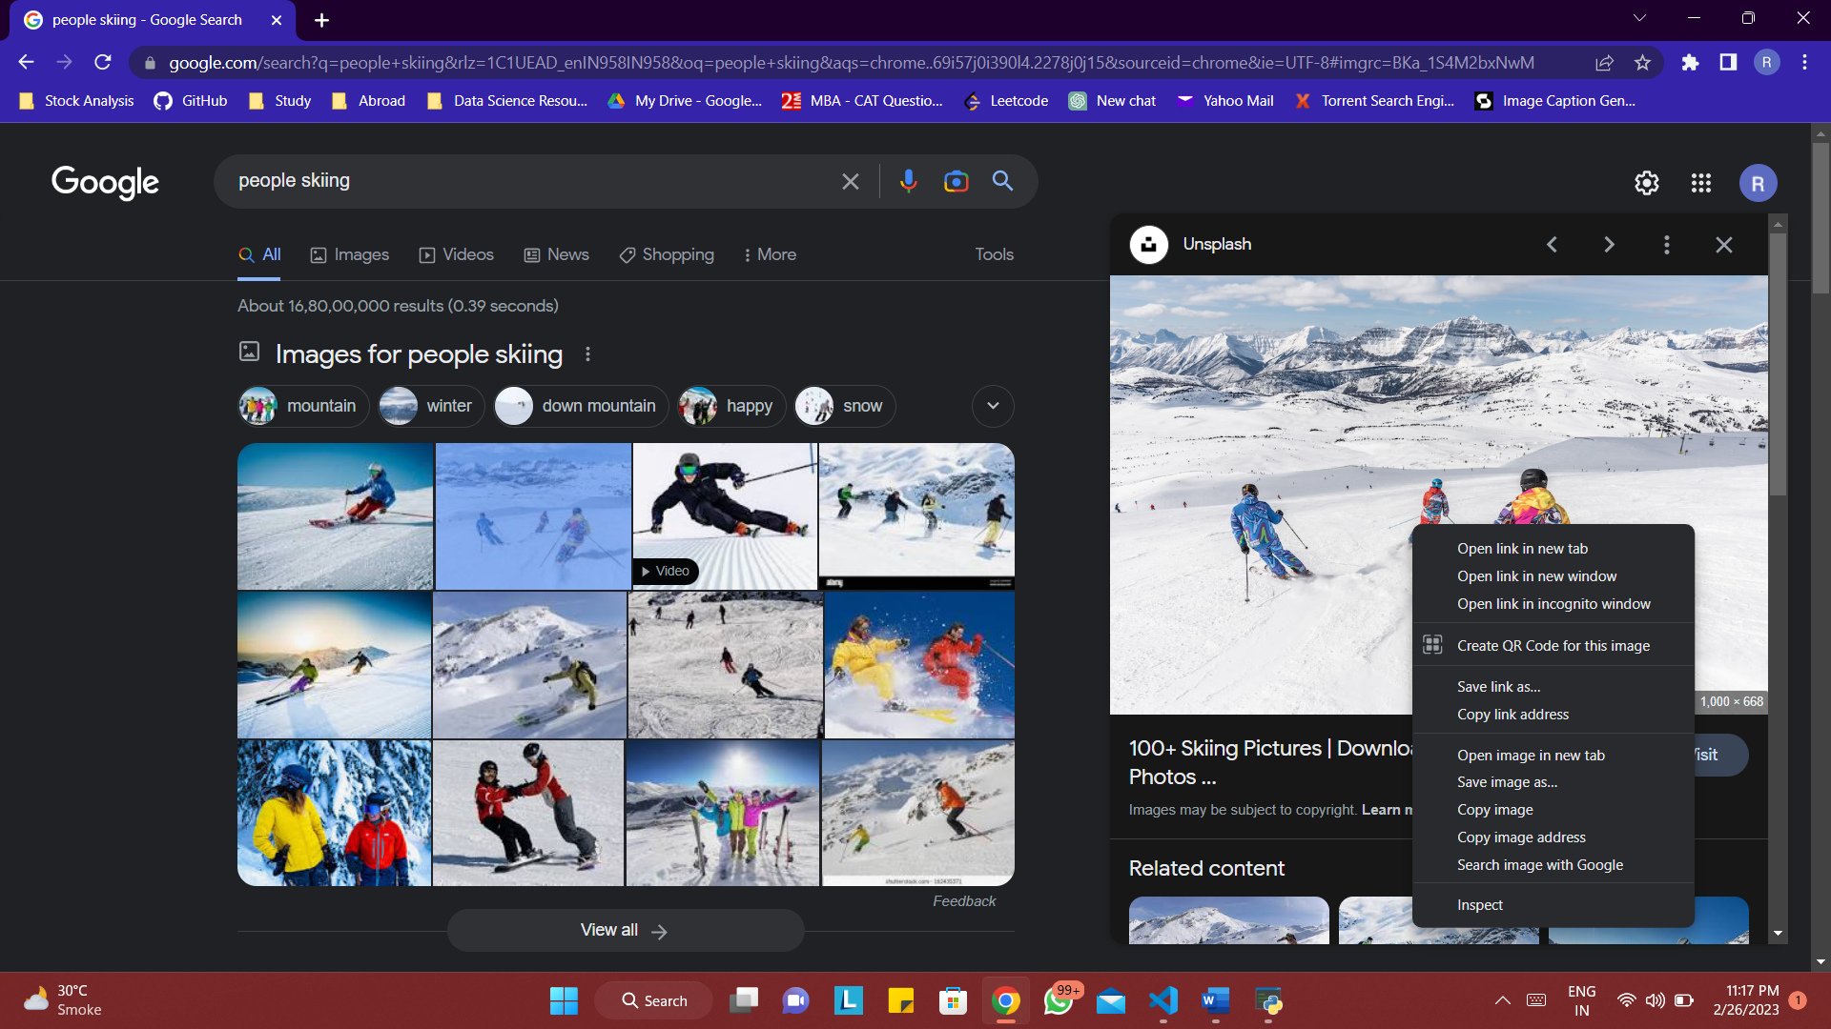

Figure 16: Fetch image from Google

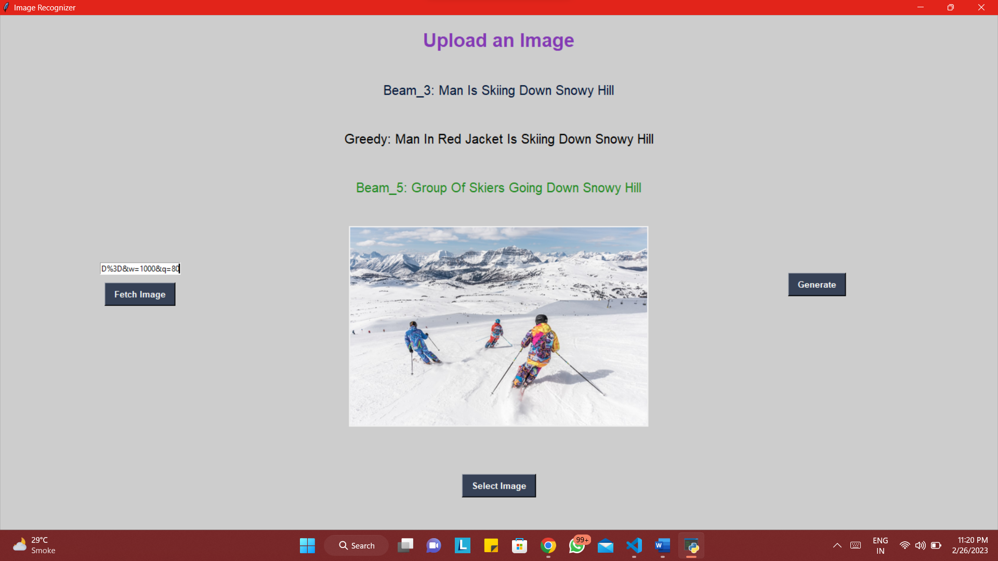

Figure 17: Check Image

1. **IMPLEMENTATION AND TESTING**

## Implementation Approach

### Introduction

The website starts with the Homepage. The Homepage has an upload image button to select images from system and a textfield where you can enter the url to image which you want to fetch. As soon as the image is uploaded then you use the generate button to generate captions for the image and then as soon the caption are generated, the algorithm will automatically check if the image is restricted or harmful and is it is one of those then it will give you a warning that the image will be taken down soon.

### Input and Output Design Implementation

This project was created by first deciding on the number of modules to be made, along with the functionalities provided to the user.

### Code Module

This Activity demonstrates the technologies used for the Front-End and Back-End. I am using the python Tkinter framework for my front end.

### System Implementation

* The website starts with the Homepage. The Homepage has an upload image button to select images from system and a textfield where you can enter the url to image which you want to fetch. As soon as the image is uploaded then you use the generate button to generate captions for the image and then as soon the caption are generated, the algorithm will automatically check if the image is restricted or harmful and is it is one of those then it will give you a warning that the image will be taken down soon.

### Project Summary

After loading the website the user is presented with the Homepage of the system which can redirect the user to the following main pages, upload image from files, upload url and fetch image, generate image caption, check and classify image.

* 1. **Code Details and Code Efficiency**

**Gui.py**

|  |
| --- |
| **from tkinter import filedialog**  **from tkinter import \***  **from PIL import ImageTk, Image**  **import numpy as np**  **import wget**  **from tensorflow.keras.models import load_model**  **from tensorflow.keras.preprocessing.sequence import pad_sequences**  **from tensorflow.keras.models import Model**  **from tensorflow.keras.applications.inception_v3 import InceptionV3, preprocess_input**  **from pickle import load**  **from tensorflow.keras.preprocessing.image import load_img, img_to_array**  **import tkinter as tk**  **base_model = InceptionV3(weights = 'inception_v3_weights_tf_dim_ordering_tf_kernels.h5')**  **vgg_model = Model(base_model.input, base_model.layers[-2].output)**  **def preprocess_img(img_path):**  **#inception v3 excepts img in 299*299**  **img = load_img(img_path, target_size = (299, 299))**  **x = img_to_array(img)**  **# Add one more dimension**  **x = np.expand_dims(x, axis = 0)**  **x = preprocess_input(x)**  **return x**  **def encode(image):**  **image = preprocess_img(image)**  **vec = vgg_model.predict(image)**  **vec = np.reshape(vec, (vec.shape[1]))**  **return vec**  **pickle_in = open("wordtoix.pkl", "rb")**  **wordtoix = load(pickle_in)**  **pickle_in = open("ixtoword.pkl", "rb")**  **ixtoword = load(pickle_in)**  **max_length = 74**  **def greedy_search(pic):**  **start = 'startseq'**  **for i in range(max_length):**  **seq = [wordtoix[word] for word in start.split() if word in wordtoix]**  **seq = pad_sequences([seq], maxlen = max_length)**  **yhat = model.predict([pic, seq])**  **yhat = np.argmax(yhat)**  **word = ixtoword[yhat]**  **start += ' ' + word**  **if word == 'endseq':**  **break**  **final = start.split()**  **final = final[1:-1]**  **final = ' '.join(final)**  **return final**  **def beam_search(image, beam_index = 3):**  **start = [wordtoix["startseq"]]**  **# start_word[0][0] = index of the starting word**  **# start_word[0][1] = probability of the word predicted**  **start_word = [[start, 0.0]]**  **while len(start_word[0][0]) < max_length:**  **temp = []**  **for s in start_word:**  **par_caps = pad_sequences([s[0]], maxlen=max_length)**  **e = image**  **preds = model.predict([e, np.array(par_caps)])**  **# Getting the top <beam_index>(n) predictions**  **word_preds = np.argsort(preds[0])[-beam_index:]**  **# creating a new list so as to put them via the model again**  **for w in word_preds:**  **next_cap, prob = s[0][:], s[1]**  **next_cap.append(w)**  **prob += preds[0][w]**  **temp.append([next_cap, prob])**  **start_word = temp**  **# Sorting according to the probabilities**  **start_word = sorted(start_word, reverse=False, key=lambda l: l[1])**  **# Getting the top words**  **start_word = start_word[-beam_index:]**  **start_word = start_word[-1][0]**  **intermediate_caption = [ixtoword[i] for i in start_word]**  **final_caption = []**  **for i in intermediate_caption:**  **if i != 'endseq':**  **final_caption.append(i)**  **else:**  **break**  **final_caption = ' '.join(final_caption[1:])**  **return final_caption**  **model = load_model('new-model-1.h5')**  **top=tk.Tk()**  **top.geometry('800x600')**  **top.title('Image Recognizer')**  **top.configure(background='#CDCDCD')**  **label2=Label(top,background='#CDCDCD', font=('Helvetica',15))**  **label1=Label(top,background='#CDCDCD', font=('Helvetica',15))**  **label=Label(top,background='#CDCDCD', font=('Helvetica',15))**  **sign_image = Label(top)**  **def classify(file_path):**  **global label_packed**  **enc = encode(file_path)**  **image = enc.reshape(1, 2048)**  **greedy = greedy_search(image)**  **print(greedy)**  **label.configure(foreground='#000', text= 'Greedy: ' + greedy.title())**  **label.pack(side=BOTTOM,expand=True)**  **beam_3 = beam_search(image)**  **print(beam_3)**  **label1.configure(foreground='#011638', text = 'Beam_3: ' + beam_3.title())**  **label1.pack(side = BOTTOM, expand = True)**  **beam_5 = beam_search(image, 5)**  **print(beam_5)**  **label2.configure(foreground='#228B22', text = 'Beam_5: ' + beam_5.title())**  **label2.pack(side = BOTTOM, expand = True)**  **final = greedy+" "+beam_3+" "+beam_5**  **print(final)**  **finall = set(final.split(' '))**  **print(finall)**  **rest = ['bikinis','gun','weapon','guns','weapons','knife']**  **for i in finall:**  **print(i)**  **if i in rest:**  **tk.messagebox.showinfo("Restricted Content!","This image contains abusive or restricted content and will be taken down")**  **break**    **def show_classify_button(file_path):**  **classify_b = Button(top,text="Generate",command=lambda: classify(file_path),padx=10,pady=5)**  **classify_b.configure(background='#364156', foreground='white',font=('Helvetica',10,'bold'))**  **classify_b.place(relx=0.79,rely=0.50)**    **def open_file(file_path):**  **try:**  **uploaded=Image.open(file_path)**  **uploaded.thumbnail(((top.winfo_width()/1.75),(top.winfo_height()/1.75)))**  **im=ImageTk.PhotoImage(uploaded)**  **sign_image.configure(image=im)**  **sign_image.image=im**  **show_classify_button(file_path)**  **except:**  **tk.messagebox.showinfo("Error!","This file is not supported or either you have entered url in wrong format")**    **def upload_image():**  **try:**  **file_path=filedialog.askopenfilename()**  **open_file(file_path)**  **except:**  **tk.messagebox.showinfo("Error!","This file is not supported or either you have entered url in wrong format")**  **def fetch_image():**  **try:**  **pic_url = entry.get()**  **file_path = wget.download(pic_url)**  **open_file(file_path)**  **except:**  **tk.messagebox.showinfo("Error!","This file is not supported or either you have entered url in wrong format")**    **entry = tk.Entry(top)**  **entry.insert(0,"Enter a url")**  **entry.place(relx=0.1,rely=0.48)**  **fetch = Button(text="Fetch Image",command=fetch_image,padx=10,pady=5)**  **fetch.configure(background='#364156', foreground='white',font=('Helvetica',10,'bold'))**  **fetch.place(relx=0.105,rely=0.52)**  **upload=Button(top,text="Select Image",command=upload_image,padx=10,pady=5)**  **upload.configure(background='#364156', foreground='white',font=('Helvetica',10,'bold'))**  **upload.pack(side=BOTTOM,pady=50)**  **sign_image.pack(side=BOTTOM,expand=True)**  **label2.pack(side = BOTTOM, expand = True)**  **heading = Label(top, text="Upload an Image",pady=20, font=('Helvetica',22,'bold'))**  **heading.configure(background='#CDCDCD',foreground='#833AB4')**  **heading.pack()**  **top.mainloop()** |

**training_model.py**

|  |
| --- |
| **import numpy as np**  **import pandas as pd**  **import os**  **import tensorflow as tf**  **from keras.preprocessing.sequence import pad_sequences**  **from keras.preprocessing.text import Tokenizer**  **from keras.models import Model**  **from keras.layers import Flatten, Dense, LSTM, Dropout, Embedding, Activation**  **from keras.layers import concatenate, BatchNormalization, Input**  **from keras.layers.merge import add**  **from keras.utils import to_categorical**  **from keras.applications.inception_v3 import InceptionV3, preprocess_input**  **from keras.utils import plot_model**  **import matplotlib.pyplot as plt**  **import cv2**  **import string**  **import time**  **print("Running.....")**  **token_path = '/kaggle/input/flickr8k/flickr_data/Flickr_Data/Flickr_TextData/Flickr8k.token.txt'**  **text = open(token_path, 'r', encoding = 'utf-8').read()**  **print(text[:500])**  **def load_description(text):**  **mapping = dict()**  **for line in text.split("\n"):**  **token = line.split("\t")**  **if len(line) < 2:**  **continue**  **img_id = token[0].split('.')[0]**  **img_des = token[1]**  **if img_id not in mapping:**  **mapping[img_id] = list()**  **mapping[img_id].append(img_des)**  **return mapping**  **descriptions = load_description(text)**  **print("Number of items: " + str(len(descriptions)))**  **descriptions['1000268201_693b08cb0e']**  **def clean_description(desc):**  **for key, des_list in desc.items():**  **for i in range(len(des_list)):**  **caption = des_list[i]**  **caption = [ch for ch in caption if ch not in string.punctuation]**  **caption = ''.join(caption)**  **caption = caption.split(' ')**  **caption = [word.lower() for word in caption if len(word)>1 and word.isalpha()]**  **caption = ' '.join(caption)**  **des_list[i] = caption**  **clean_description(descriptions)**  **descriptions['1000268201_693b08cb0e']**  **def to_vocab(desc):**  **words = set()**  **for key in desc.keys():**  **for line in desc[key]:**  **words.update(line.split())**  **return words**  **vocab = to_vocab(descriptions)**  **len(vocab)**  **import glob**  **images = '/kaggle/input/flickr8k/flickr_data/Flickr_Data/Images/'**  **# Create a list of all image names in the directory**  **img = glob.glob(images + '*.jpg')**  **len(img)**  **train_path = '/kaggle/input/flickr8k/flickr_data/Flickr_Data/Flickr_TextData/Flickr_8k.trainImages.txt'**  **train_images = open(train_path, 'r', encoding = 'utf-8').read().split("\n")**  **train_img = []**  **for im in img:**  **if(im[len(images):] in train_images):**  **train_img.append(im)**  **test_path = '/kaggle/input/flickr8k/flickr_data/Flickr_Data/Flickr_TextData/Flickr_8k.testImages.txt'**  **test_images = open(test_path, 'r', encoding = 'utf-8').read().split("\n")**  **test_img = []**  **for im in img:**  **if(im[len(images): ] in test_images):**  **test_img.append(im)**  **len(test_img)**  **#load descriptions of train and test set separately**  **def load_clean_descriptions(des, dataset):**  **dataset_des = dict()**  **for key, des_list in des.items():**  **if key+'.jpg' in dataset:**  **if key not in dataset_des:**  **dataset_des[key] = list()**  **for line in des_list:**  **desc = 'startseq ' + line + ' endseq'**  **dataset_des[key].append(desc)**  **return dataset_des**  **train_descriptions = load_clean_descriptions(descriptions, train_images)**  **print('Descriptions: train=%d' % len(train_descriptions))**  **train_descriptions['1000268201_693b08cb0e']**  **from keras.preprocessing.image import load_img, img_to_array**  **def preprocess_img(img_path):**  **#inception v3 excepts img in 299*299**  **img = load_img(img_path, target_size = (299, 299))**  **x = img_to_array(img)**  **# Add one more dimension**  **x = np.expand_dims(x, axis = 0)**  **x = preprocess_input(x)**  **return x**  **base_model = InceptionV3(weights = 'imagenet')**  **base_model.summary()**  **model = Model(base_model.input, base_model.layers[-2].output)**  **#function to encode an image into a vector using inception v3**  **def encode(image):**  **image = preprocess_img(image)**  **vec = model.predict(image)**  **vec = np.reshape(vec, (vec.shape[1]))**  **return vec**  **#run the encode function on all train images**  **start = time.time()**  **encoding_train = {}**  **for img in train_img:**  **encoding_train[img[len(images):]] = encode(img)**  **print("Time Taken is: " + str(time.time() - start))**  **#Encode all the test images**  **start = time.time()**  **encoding_test = {}**  **for img in test_img:**  **encoding_test[img[len(images):]] = encode(img)**  **print("Time taken is: " + str(time.time() - start))**  **train_features = encoding_train**  **test_features = encoding_test**  **print("Train image encodings: " + str(len(train_features)))**  **print("Test image encodings: " + str(len(test_features)))**  **train_features['1000268201_693b08cb0e.jpg'].shape**  **#list of all training captions**  **all_train_captions = []**  **for key, val in train_descriptions.items():**  **for caption in val:**  **all_train_captions.append(caption)**  **len(all_train_captions)**  **#onsider only words which occur atleast 10 times**  **vocabulary = vocab**  **threshold = 10**  **word_counts = {}**  **for cap in all_train_captions:**  **for word in cap.split(' '):**  **word_counts[word] = word_counts.get(word, 0) + 1**  **vocab = [word for word in word_counts if word_counts[word] >= threshold]**  **print("Unique words: " + str(len(word_counts)))**  **print("our Vocabulary: " + str(len(vocab)))**  **#word mapping to integers**  **ixtoword = {}**  **wordtoix = {}**  **ix = 1**  **for word in vocab:**  **wordtoix[word] = ix**  **ixtoword[ix] = word**  **ix += 1**  **vocab_size = len(ixtoword) + 1 #1 for appended zeros**  **vocab_size**  **#find the maximum length of a description in a dataset**  **max_length = max(len(des.split()) for des in all_train_captions)**  **max_length**  **#since there are almost 30000 descriptions to process we will use datagenerator**  **X1, X2, y = list(), list(), list()**  **for key, des_list in train_descriptions.items():**  **pic = train_features[key + '.jpg']**  **for cap in des_list:**  **seq = [wordtoix[word] for word in cap.split(' ') if word in wordtoix]**  **for i in range(1, len(seq)):**  **in_seq, out_seq = seq[:i], seq[i]**  **in_seq = pad_sequences([in_seq], maxlen = max_length)[0]**  **out_seq = to_categorical([out_seq], num_classes = vocab_size)[0]**  **#store**  **X1.append(pic)**  **X2.append(in_seq)**  **y.append(out_seq)**  **X2 = np.array(X2)**  **X1 = np.array(X1)**  **y = np.array(y)**  **print(X1.shape)**  **#load glove vectors for embedding layer**  **embeddings_index = {}**  **glove = open('/kaggle/input/glove-global-vectors-for-word-representation/glove.6B.200d.txt', 'r', encoding = 'utf-8').read()**  **for line in glove.split("\n"):**  **values = line.split(" ")**  **word = values[0]**  **indices = np.asarray(values[1: ], dtype = 'float32')**  **embeddings_index[word] = indices**  **print('Total word vectors: ' + str(len(embeddings_index)))**  **emb_dim = 200**  **emb_matrix = np.zeros((vocab_size, emb_dim))**  **for word, i in wordtoix.items():**  **emb_vec = embeddings_index.get(word)**  **if emb_vec is not None:**  **emb_matrix[i] = emb_vec**  **emb_matrix.shape**  **# define the model**  **ip1 = Input(shape = (2048, ))**  **fe1 = Dropout(0.2)(ip1)**  **fe2 = Dense(256, activation = 'relu')(fe1)**  **ip2 = Input(shape = (max_length, ))**  **se1 = Embedding(vocab_size, emb_dim, mask_zero = True)(ip2)**  **se2 = Dropout(0.2)(se1)**  **se3 = LSTM(256)(se2)**  **decoder1 = add([fe2, se3])**  **decoder2 = Dense(256, activation = 'relu')(decoder1)**  **outputs = Dense(vocab_size, activation = 'softmax')(decoder2)**  **model = Model(inputs = [ip1, ip2], outputs = outputs)**  **model.summary()**  **model.layers[2]**  **model.layers[2].set_weights([emb_matrix])**  **model.layers[2].trainable = False**  **model.compile(loss = 'categorical_crossentropy', optimizer = 'adam')**  **plot_model(model, to_file = 'model.png', show_shapes = True, show_layer_names = True)**  **for i in range(30):**  **model.fit([X1, X2], y, epochs = 1, batch_size = 256)**  **if(i%2 == 0):**  **model.save_weights("image-caption-weights" + str(i) + ".h5")**  **def greedy_search(pic):**  **start = 'startseq'**  **for i in range(max_length):**  **seq = [wordtoix[word] for word in start.split() if word in wordtoix]**  **seq = pad_sequences([seq], maxlen = max_length)**  **yhat = model.predict([pic, seq])**  **yhat = np.argmax(yhat)**  **word = ixtoword[yhat]**  **start += ' ' + word**  **if word == 'endseq':**  **break**  **final = start.split()**  **final = final[1:-1]**  **final = ' '.join(final)**  **return final**  **pic = list(encoding_test.keys())[250]**  **img = encoding_test[pic].reshape(1, 2048)**  **x = plt.imread(images + pic)**  **plt.imshow(x)**  **plt.show()**  **print(greedy_search(img))**  **pic = list(encoding_test.keys())[570]**  **img = encoding_test[pic].reshape(1, 2048)**  **x = plt.imread(images + pic)**  **plt.imshow(x)**  **plt.show()**  **print(greedy_search(img))**  **model.save("my_model.h5")**  **#train it for some more time**  **model.fit([X1, X2], y, epochs = 1, batch_size = 64)**  **model.save("my_model_"+str(i)+".h5")**  **pic = list(encoding_test.keys())[888]**  **img = encoding_test[pic].reshape(1, 2048)**  **x = plt.imread(images + pic)**  **plt.imshow(x)**  **plt.show()**  **print(greedy_search(img))**  **model.save("my-cap.h5")** |

**5.2.1 Code Efficiency**

The Django framework makes use of python and html which helps code efficiency. It makes use of different files and folders for the database logic and website logic which makes it easier to read and understand.

**5.3 Testing Approach**

Following testing approaches have been performed on the system: Unit Testing, Integration Testing, System Testing

5.3.1 Unit Testing

Unit Testing is done by Testing each module as a separate function. Every module in the project is tested separately. For Eg: The Menu module was tested separately to make sure the details are added in the database.

5.3.2 Integration Testing

Integration Testing means Testing more than one Module at a time. For Eg:

Testing the Create MenuItem module with the Display Menu module. The

MenuItem created should be displayed in the display Menu module.

5.3.3 System Testing

System testing has been performed on a completely integrated system to assess

whether the system meets the requirements and passes the test cases defined

above. The web application has successfully met all the criteria and has passed

all the tests as separate units and as a completely integrated system.

* 1. **MODIFICATIONS AND IMPROVEMENTS**

After testing and handling all errors, exceptions and bugs, errors were solved by troubleshooting, exceptions were handled by try catch block at the correct places avoiding redundancy of code from index files. Bugs can never be removed completely but most of them are solved and remaining are under development. The project can be further improved by adding the functionality of creating an arrangement for multiple examinations with multiple courses.

**User Documantation**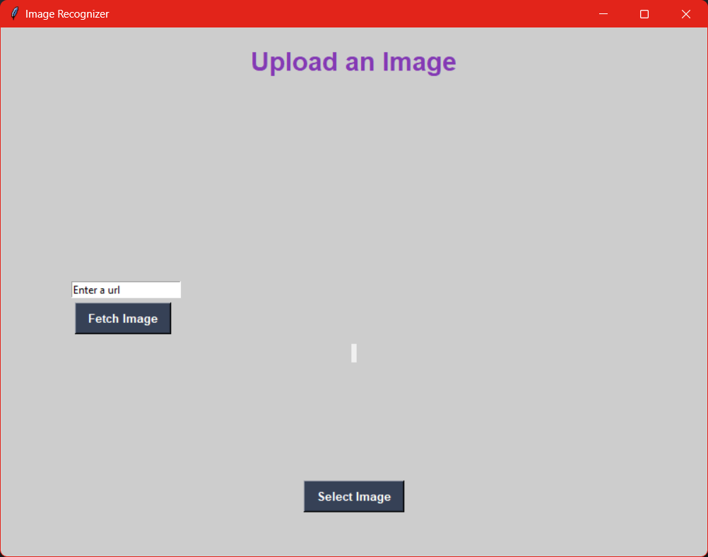

Figure 18: Homepage

Figure 19: Select an image through files

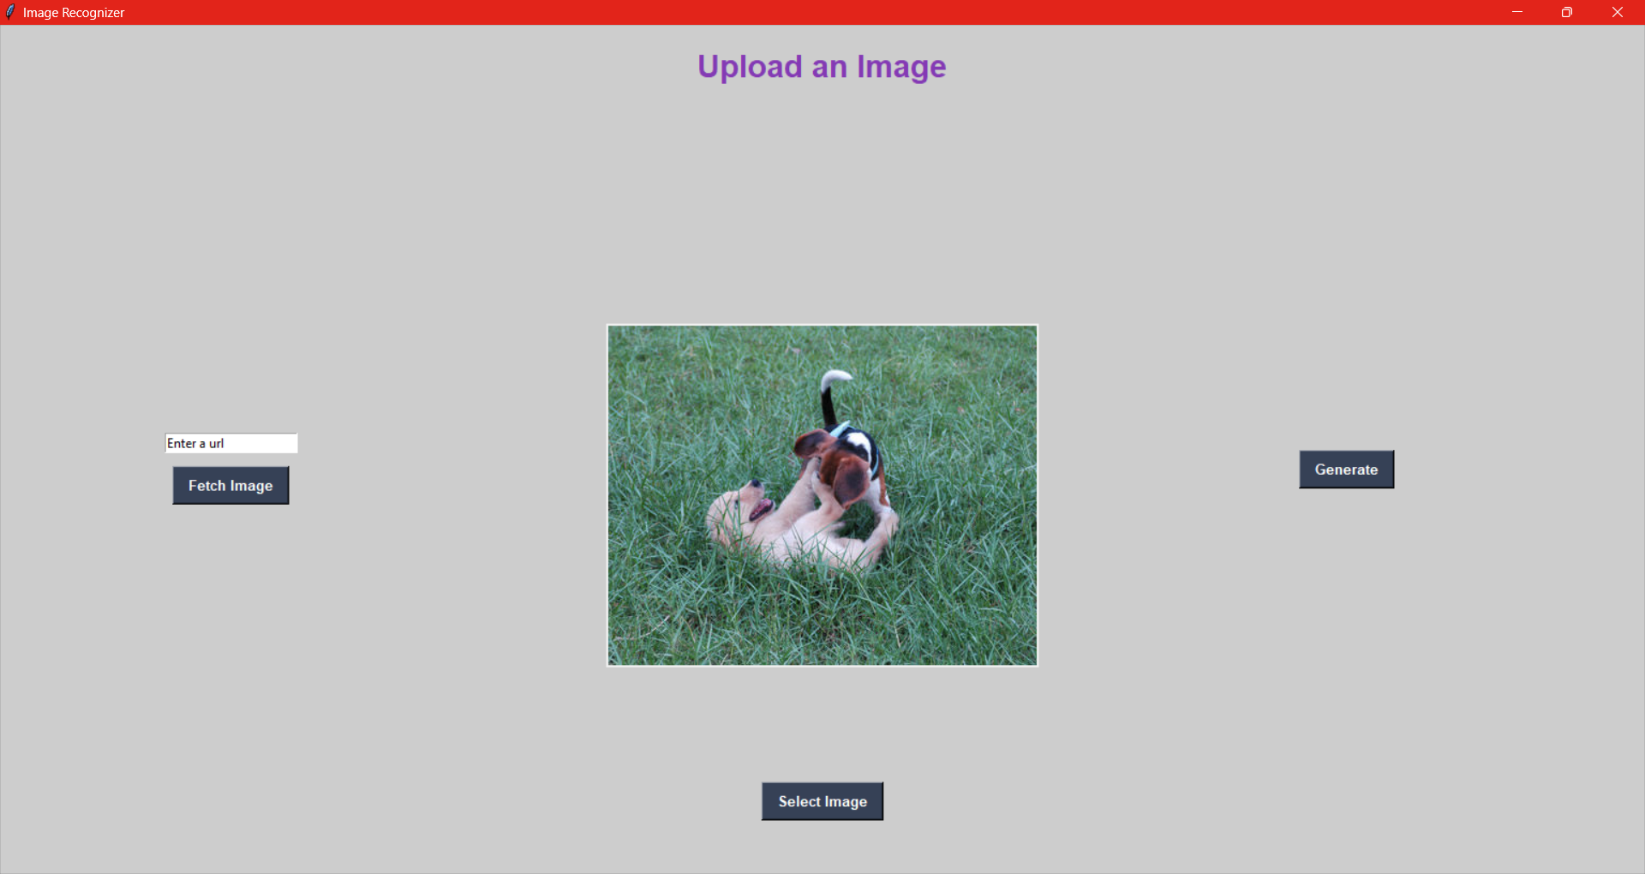

Figure 20: After selecting image

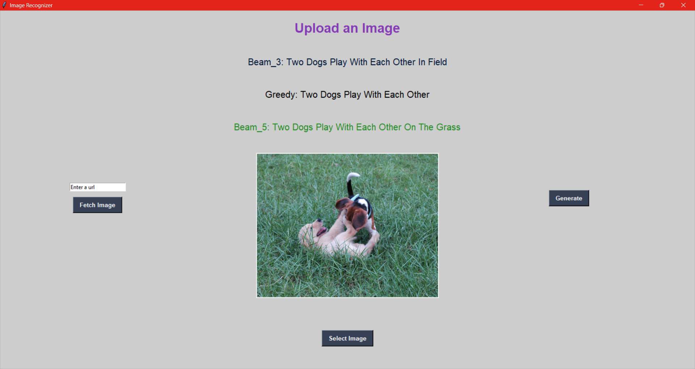

Figure 21: After Generating

Figure 22: Fetch Image address from google

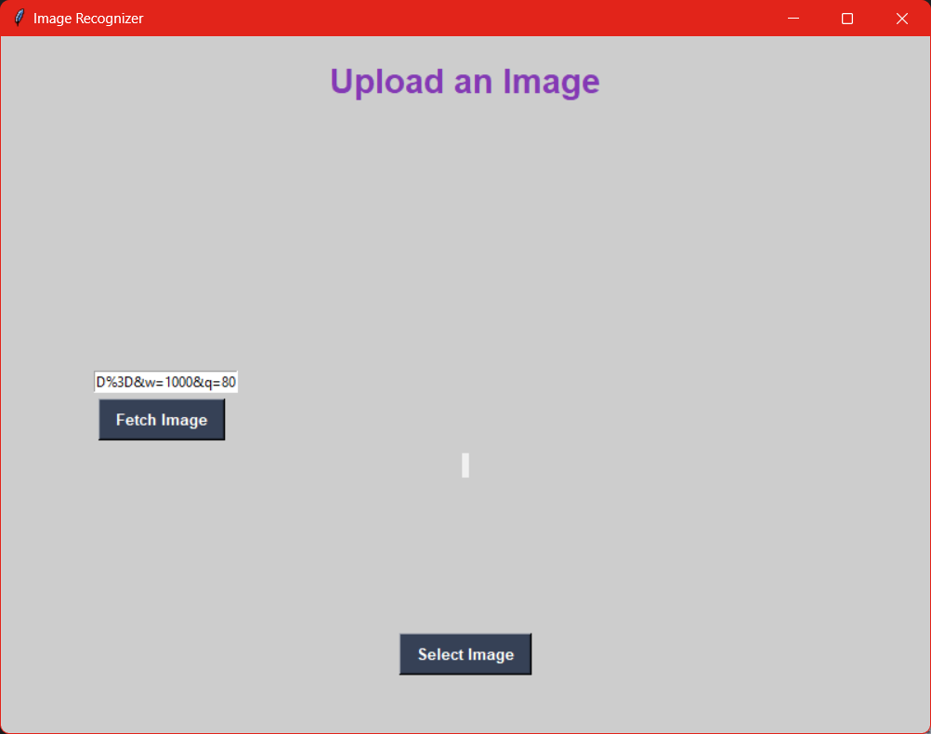

Figure 23: Enter URL

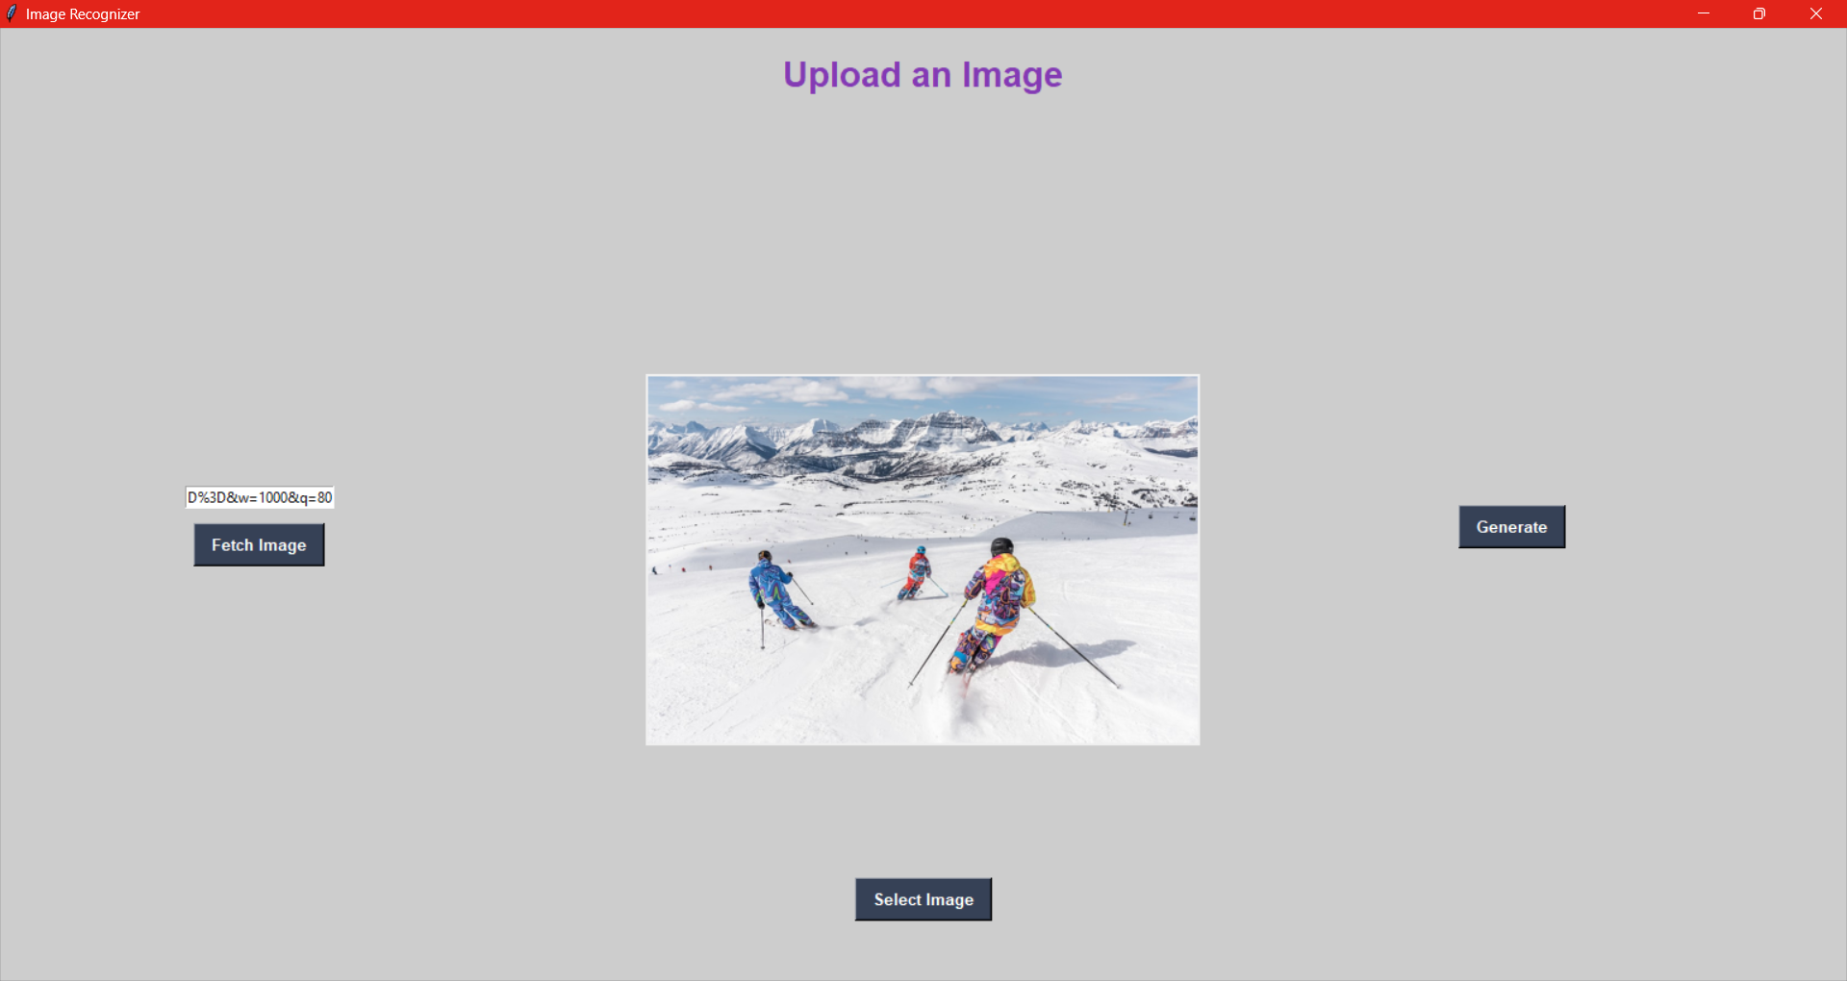

Figure 24: After fetching from google



Figure 25: Recognizing Image

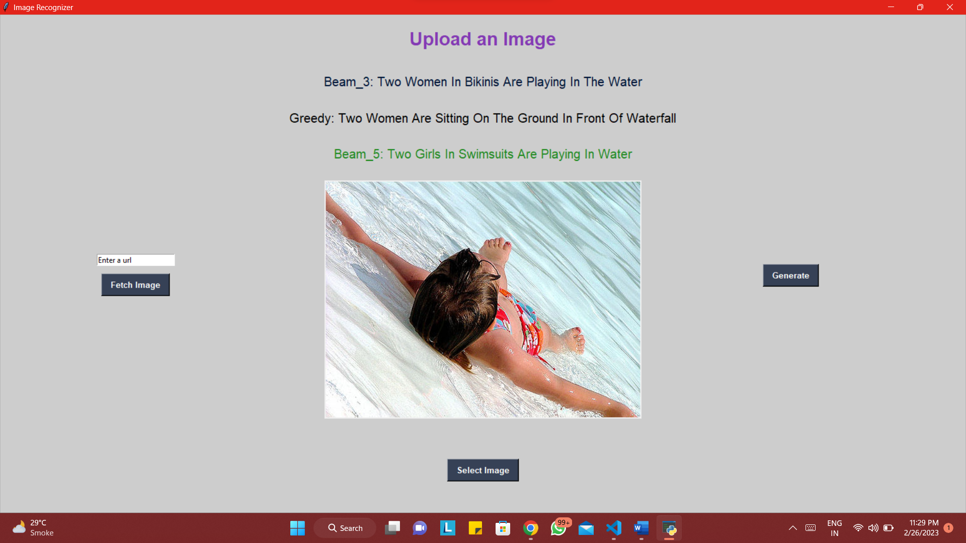

Figure 26: Uploading Image

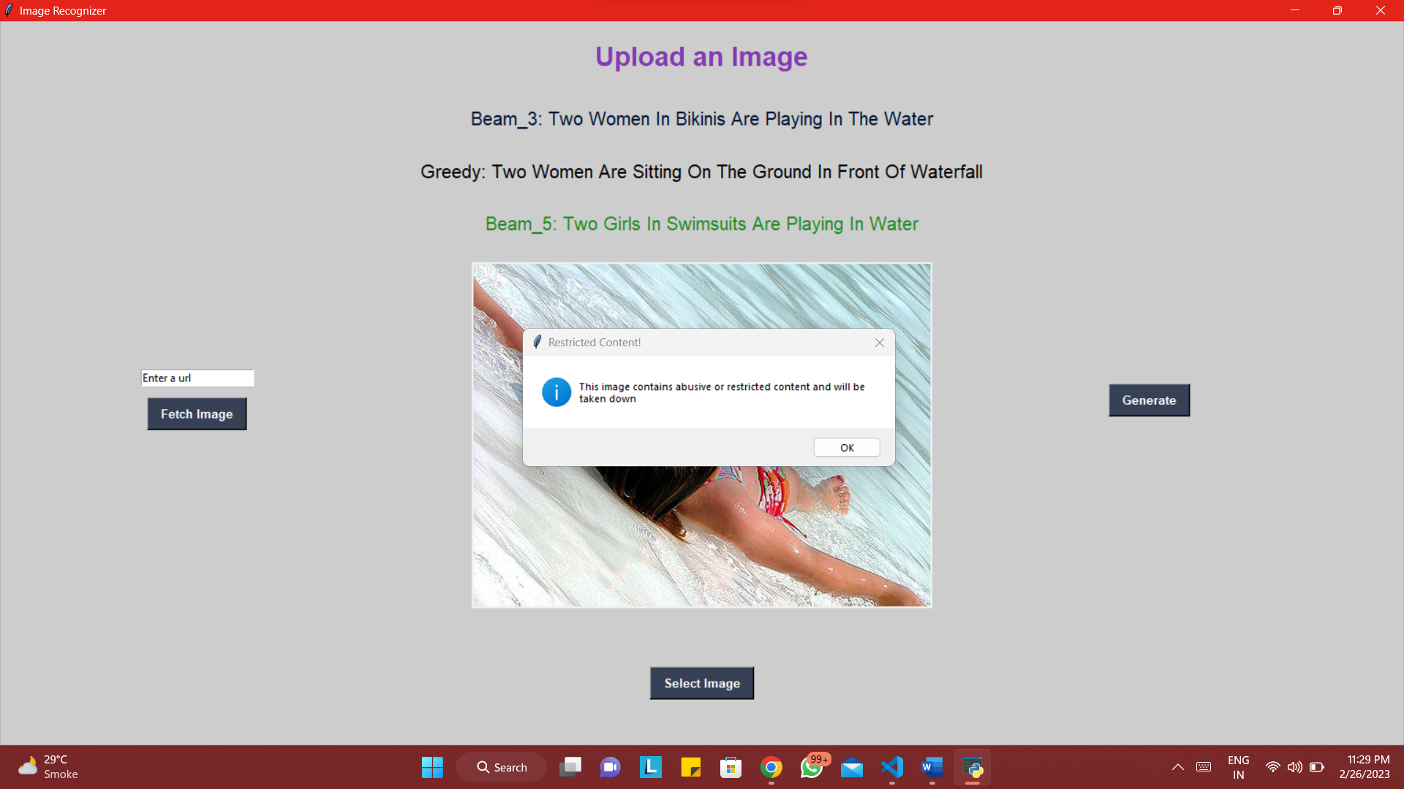

Figure 27: Recognizing Image as Harmful/Restricted Content

1. **CONCLUSION**

7.1 Conclusion

The project has been implemented according to the objectives mentioned in the beginning. The dynamic nature of the project allows an easier way to maintain the infrastructure.

7.2 Limitations

* This project requires lots and lot of training and still might not be 100% accurate. The more we train the more better it gets

7.3 Future scope of the project

* The project can be implemented in a way that allows platforms or websites to track images and classify them as restricted or not
* The project can be designed in a way that can also classify videos

# References

* https://docs.microsoft.com/
* https://social.msdn.microsoft.com/
* https://stackoverflow.com/
* [https://www.tutorialspoint.com/](http://www.tutorialspoint.com/)
* [https://www.tutorialsteacher](http://www.tutorialsteacher.com/).com/